Fazil Shaikh

Cos 470

Dec 12, 2019

Assignment 4

**Part 1:**

I made a *Snowman* piece that replaces the queen (Figure 1). It can move and capture pieces one space up, down, left, and right. Unlike other pieces however, when *Snowman* captures a piece, it turns into an *Explode* piece which explodes in a one by one explosion radius after one move (Figure 2). When it explodes, all pieces in the explosion radius, including the friendly pieces, are removed.

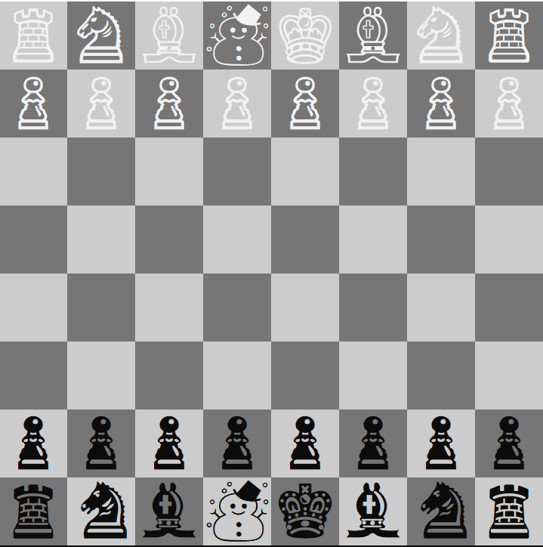

Figure 1: Snowman chess piece.

Figure 2: Here we see the white Snowman capture black Knight and then turn into the Explode piece. The Explode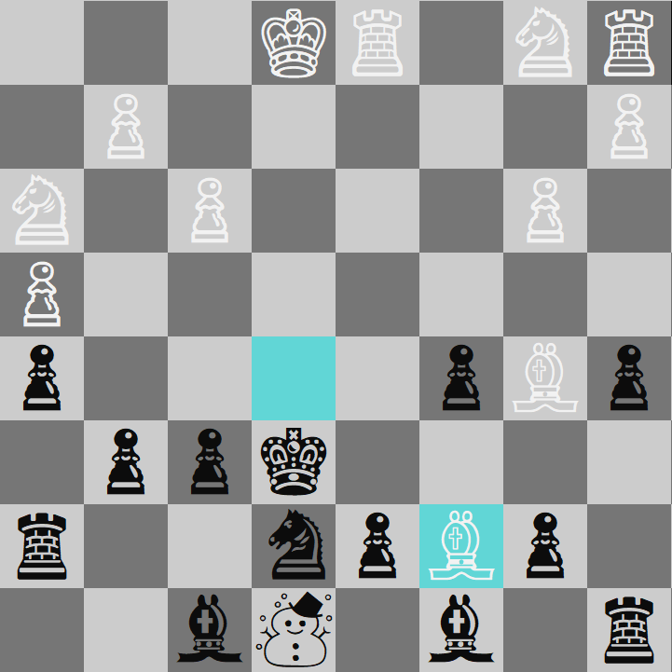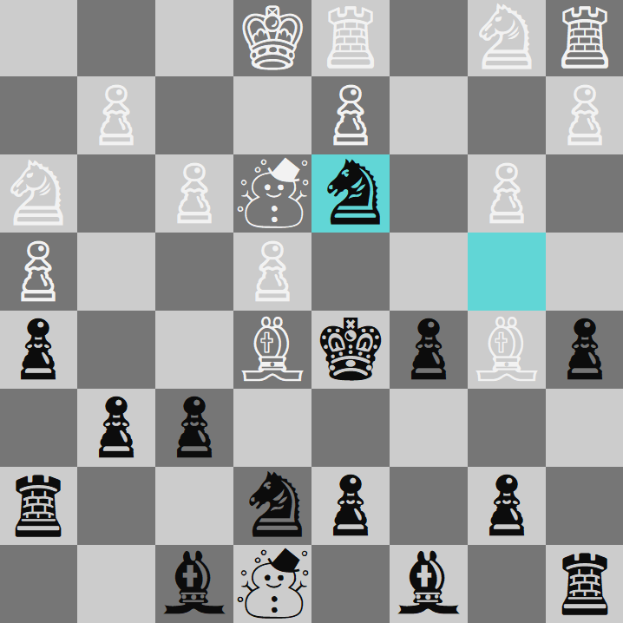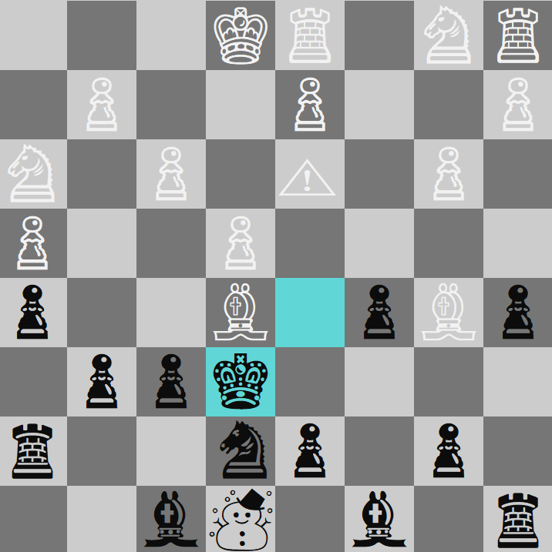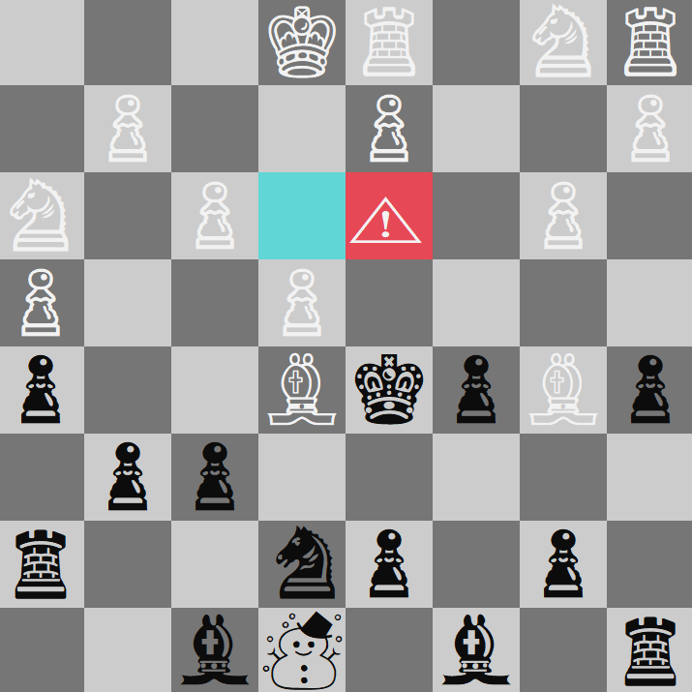

piece explodes everything near its 1x1 radius after one move.

**Part 2:**

I made a new type of “smart” chess player called SmartPlayer. It reliably beats the BasePlayer when playing as either black or white. Currently, I have to manually change the player type in ConsoleChess.cs. The default player1 is BasePlayer who plays white pieces, and default player 2 is SmartPlayer who plays black pieces.

The idea with SmartPlayer is that it checks every board option and chooses the one with more nulls on the board because they indicate a capture. Generally, when a piece is captured, it results in an extra space/null on the board. To make it more interesting and random, when there are no capture options on the board, it chooses a random move using a random number generator similar to BasePlayer.

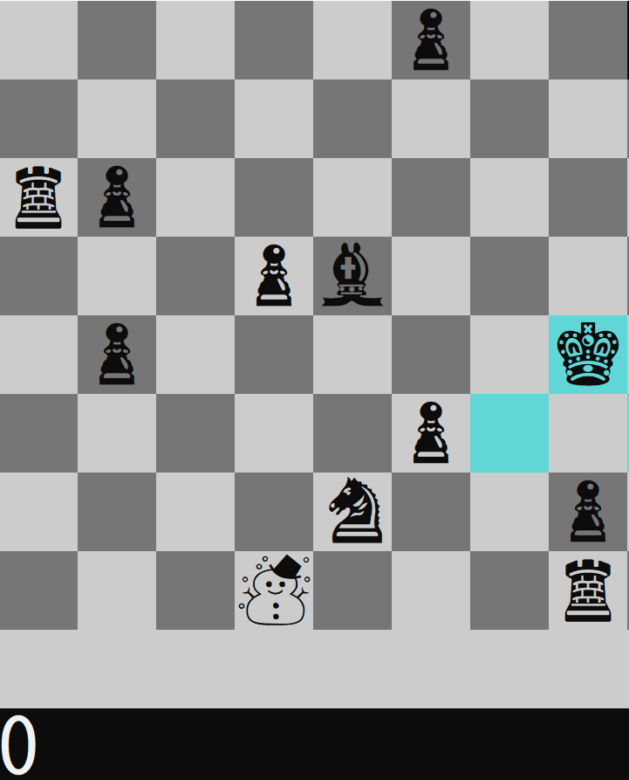

Figure 3: SmartPlayer winning (everytime).